TRAVEL TRAINING
FORMS PACKET

Developed by Institute for Community Inclusion
University of Massachusetts
Boston, MA
www.communityinclusion.org

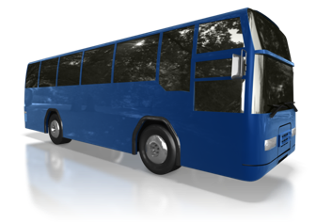
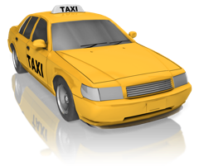

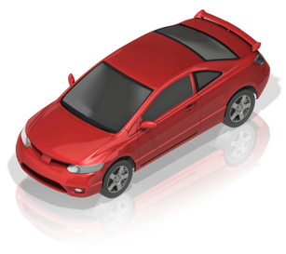
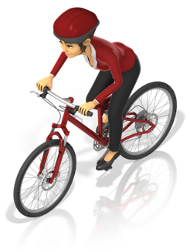
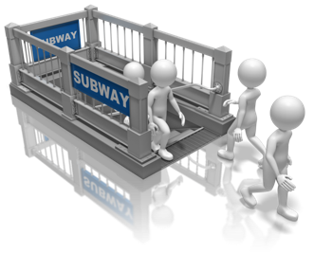

The purpose of this transportation training packet is to assist in training individuals with disabilities on taking transportation to and from work. It is designed particularly to assist individuals who experience learning challenges, and benefit from a systematic approach to learning. It is also intended as a mechanism for documenting that an individual has been properly travel trained, and contact/emergency information regarding transportation.
Transportation Information Sheet

Name: _______________________________________________________________________

Home address: _______________________________________________________________

_______________________________________________________________

Home Phone: ________________________ Cell Phone: _________________________

Emergency Contact

Name: _____________________________________________________________________

Relationship: ____________________________________
Cell phone: ______________________________________
Business phone: __________________________________
Home phone: _____________________________________

Employer

Name:

Address:

• Supervisor/Contact Name:

Phone #:

Summary of transportation to and from work:

Automobile directions to employer:

Transportation Method & Directions
Training Sheet

Name: ____________________________________________________

Date:
Step 1:

Step 2:

Step 3:

Step 4:

Step 5:

Step 6:

Step 7:

Step 8:

Step 9:

Step 10:

Step 11:

Step 12:

Step 13:

Step 14:

Key: + = Correct V = Needed verbal prompt
- = Incorrect P = Needed physical prompt

Comments: ____________________________________________________________________

_____________________________________________________________________________

Name: ____________________________________________________

Transportation Training Sheet: Prior to Leaving Home

Date:
Dressed properly for weather
Money/pass for transit
Emergency information card

Key: + = Correct V = Needed verbal prompt
- = Incorrect P = Needed physical prompt

Comments: ____________________________________________________________________

_____________________________________________________________________________

--------------------------------------------------------------------------------------------------------------------
Pedestrian Skills

Date:
Walks on sidewalk/shoulder
Crosses only at corners/crosswalks
Looks before crossing streets
Notices and reacts properly to vehicles in roadway
Obeys traffic signals

Key: + = Correct V = Needed verbal prompt
- = Incorrect P = Needed physical prompt

Comments: ____________________________________________________________________

_____________________________________________________________________________
Transportation Training Sheet: Mass Transit

Name: ____________________________________________________

Date:
Waits at proper location
Recognizes proper bus/train
Signals bus
Boards train/bus safely
Pays fare properly
Finds seat
Identifies location of driver/conductor
Recognizes where to get off
Cue:

Disembarks from Train/Bus Safely

Key: + = Correct V = Needed verbal prompt
- = Incorrect P = Needed physical prompt

Comments: ____________________________________________________________________

______________________________________________________________________________

______________________________________________________________________________

______________________________________________________________________________

______________________________________________________________________________

Transportation Training Sheet: Safety

Name: ____________________________________________________

Date:
Safety rules reviewed and followed
Location of police/safety officer noted
No talking to strangers
Don't give money to anyone
Secure pocketbook/wallet/money
Do not deviate from standard route
emergency procedures reviewed and understood
Missed train/bus
Got off at wrong stop
Lost money/fare
Stranger bothering

Key: + = Correct V = Needed verbal prompt
- = Incorrect P = Needed physical prompt

Comments: ____________________________________________________________________

______________________________________________________________________________

______________________________________________________________________________

______________________________________________________________________________

______________________________________________________________________________

